1.

(a) The covariance is defined as the expected value of the product of their deviations from their individual expected values.

Cov(X,Y) = E[(X-E[X])(Y-E[Y]))] = E[XY] -E[x]E[Y]

Px,y = Cox(X,Y)/ox oy

Using this equation (and the fact that the expectation of the product of two independent random variables is equal to the product of the expectations) is it easy to see that if two random variables are independent their covariance is 0.

(b)

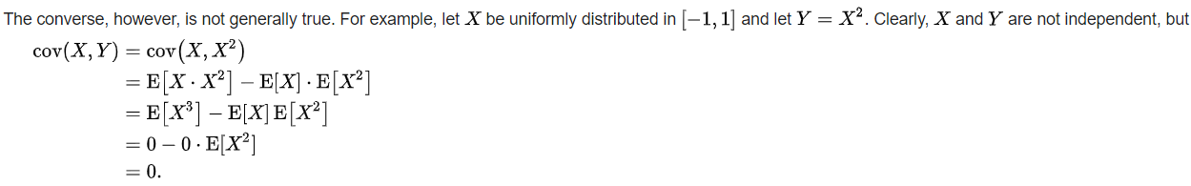

P(x=1,y=1) = 1/3; P(x=-1,y=1) = 1/3; P(x=0,y=0)=1/3

2.

3.

(a)

{T,x1,x2}{T,x1,x2,x3} {T,x2,x3}

The all paths from x0 to y are listed as follows:

X0-x1-x2-Y

X0-x1-x3-Y

X0-x1-T-Y

X0-T-Y

X0-T-x1-x2-Y

X0-T-x1-x3-Y

In each path, we analyse the available variable sets that satisfy the demand based on the definition of block path that either A or B satisfied is ok.

For (1), because x0-x1-x2 is a collider and x1-x2-y is a folk, without condition on any variables, x0 and y are d-separated. If we condition on x1 or its descendants,

(b)

(c)

(d)

frozenset({'x2', 'x3'}),

frozenset({'x0', 'x1', 'x3'}),

frozenset({'x1', 'x2'}),

frozenset({'x0', 'x1'}),

frozenset({'x0', 'x2', 'x3'}),

frozenset({'x0', 'x1', 'x2'}),

frozenset({'x1', 'x2', 'x3'}),

frozenset({'x0', 'x1', 'x2', 'x3'})

(e)